


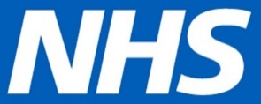
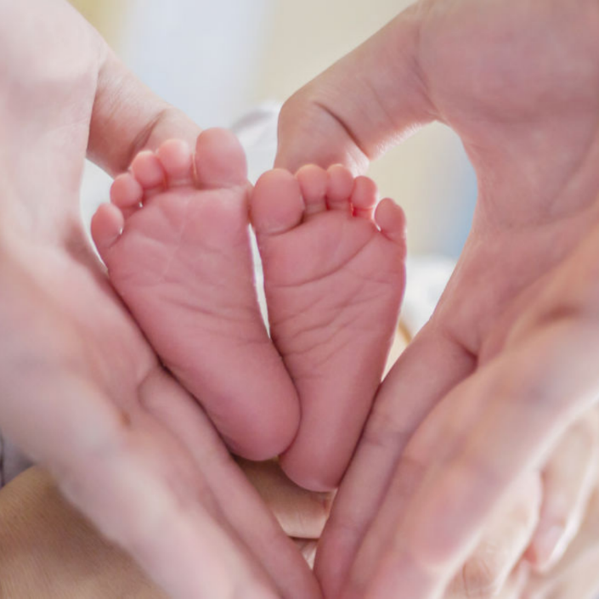
Who is organising the survey?

below.
22-059168-01
_Maternity_A4
If you do not wish to take part, do not wish for your details to be shared with researchers so you can be sent a questionnaire, or if you have any questions about the survey, then please let us know by the end of March using the contact details below.
TELL US ABOUT YOUR CARE
I do not wish to take part. What do I do?
The survey is being carried out by researchers from this NHS Trust (or independent contractor staff that they employ), the Care Quality Commission and the Survey Coordination Centre at Picker. The results will be presented in a form that does not allow any individual’s answers to be identified.
If you do not want to take part, or have any questions about the survey please contact:
[Trust phone number- this is required]
[Trust email address- if available]
[Trust address- if available]
2026 NHS Maternity Survey
We will shortly be conducting a survey about the care you received during pregnancy and after your birth. This survey is part of a national programme to improve experiences of maternity care.

Your feedback is important to us
If you are invited to take part, the trust will pass on your contact details (name, mobile telephone number and postal address) so researchers can get in touch with you about the survey.
If you complete the survey, your name and full address will never be linked to your responses.

Taking part in the survey is voluntary and all answers are confidential.
Your views are important to us
It is very important for us to find out what people across England think of the maternity care they have received, so the NHS can make improvements.
If you fill out the questionnaire, your answers will be put together with the answers of others to provide results for your trust. This will be kept confidential by the researchers. Nobody will be able to identify you in any results that are published, and the trust will not know who has taken part.

Why are you asking me to take part?
You may be sent a letter inviting you to take part in this important survey in a few months’ time because you recently had a baby. We are asking other people who gave birth during the same period to take part in the survey. Survey invitations will be sent out in April, May and June 2026.

Do I have to take part?
No. Taking part in this survey is voluntary but your views are really important to us. If you do not wish to take part, it will not affect the care you receive from the NHS. You can decide not to take part, or if you do not want to answer some of the questions, you can do so without giving a reason.

If I take part, will my answers be kept confidential?
Yes. The information you give us will be held securely and will be treated in strict confidence in accordance with the General Data Protection Regulation. We will give you a unique number so that your name and address is not on the questionnaire, and your name and full address will never be linked to your responses. We will use your anonymous responses to provide information about the quality of the services the trust provides and to help us improve these services. All personal information you provide will be destroyed within six months of you taking part in the survey.

